Online Bank Management

Group details:

* Asif Hossain Neloy - 20-42996-1
* MD. Mamunur Rahman Moon - 20-42439-1
* Abrar Rahman - 20-42458-1
* Nafijul Haque - 20-42366-1

Showing all the values in the tables below:

1. Bank

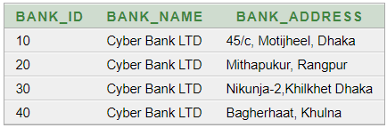

1. Employee

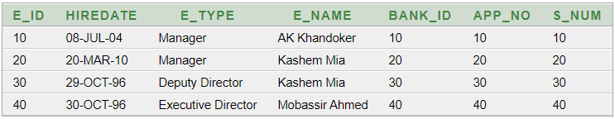

1. App

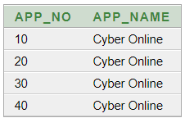

1. CustomerInfo

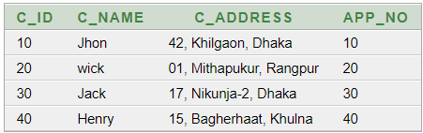

1. Customer_phone_number

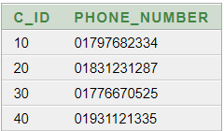

1. Loan

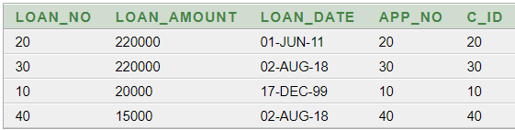

1. Account

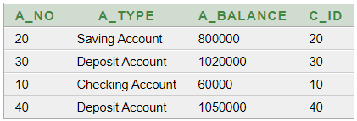

1. Transaction_records

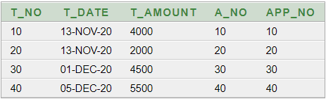

1. Salary

